Fuzzy logic Considerations

1. We will have to use mosfets to control the power being supplied to the battery
2. Is there a reference or reason why these four levels are used (NI, L, M, H)
3. Given that mosfet will be used, there is need for computation on your end on the values that will be used
4. Is there a reference why triangular method is used?
5. If blended wouldyoulike to switch to grid or use combination of both sources

Fuzzy sets determine the range of conditions which will be the basis of the fuzzy set rules

Mosfet vs relay?

If mosfet will be used,therewill be varying levels of voltage

If relay will be used,less controllability but still the same outcome.  
We will use current and possibly voltage sensor to track the power

Based on the values of power, we will check to see which source to use.

Im curious to know where you were able to get the values for

Reason: Fuzzy logic ruleset will depend on the table you have created. I’m assuming that the Rule set you have created is for outputs? Will have to know what corresponding action should I make for each of the states.

Similar as to this one:  
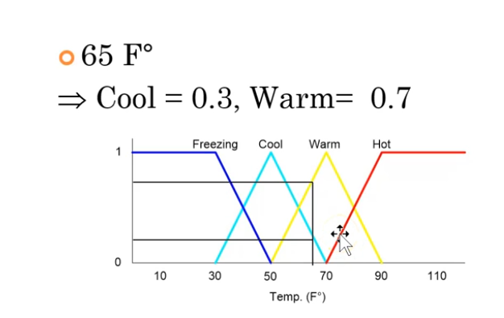

In order to create a fuzzy logic rule set,need po gumawa ng graph similar as above para maconsider po different states ng inputs and outputs.

For example, sa input sa taas. 65F is between warm and cool. May specific na output value yon sa y axis na nagsasabi kung ano yung magiging proper action ng fuzzy logic. Maybe sa case po sa taas, aircon po yon, so dapatkung between cool and warm yung temp, may appropriate na action gagawin yung aircon (i.e. bawasan yung lamig) which would be designated for that specific output.

Based sa papers niyo po may various values po kayo ng input:  
  
NI: 0 - 0.99, L: 1-39.9, M: 40-69.9, and H:

70-100. Pico-hydropower (in watts) has the following ranges: NI: 0 - 0.99, L: 1-3.9, M: 4-6.9,

and H: 7-10. Grid Power (in watts) has the following ranges: NI: 0 - 0.99, L: 1-9.36, M: 9.37-

16.56, and H: 16.57-24.

Pero sa output,which are these points po:

Negative Big (NB), Negative Small (NS), Zero (ZZ), Positive Small (PS), and Positive

Big (PB).

Ito po yung magiging consideration natin kung ano po gagawin ko para sa Fuzzy logic rule sets. Kasi di ko alam kung anong gagawin natin kapag NB yung lumabas, NS, ZZ,Positive Small (PS), or PB

Sa ngayon mosfet yung naisip ko kasi pwede maging adjustable current siya based sa gate voltage ng mosfet, as such possible for multiple outputs.

Kapag relay, either on or off lang ang states, pero given yung outputs niyo na more than 2. I think di siya feasible.

May napakita naman na si chat gpt na pwede gamitin.

Need ko din malaman sagot niyo dito kasi magiging hardware constraint din siya on our end at kung mag opt man tayo for MOSFET, kakailanganin pa po bumili ng proper component for each of the sources.

Relay for solenoid valve switching

MOSFET for input

List lang gagamitin na grid